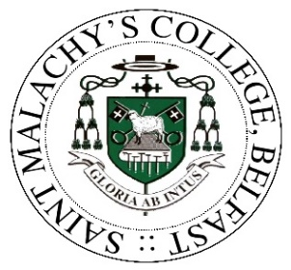
ADMISSIONS CRITERIA FOR YEAR 14 – for September 2024

In accordance with the requirements of the Department of Education, the Board of Governors of St. Malachy's College has drawn up the following criteria for admission to Sixth Form (Year 14).

1. Academic Requirements

All Year 13 students wishing to progress into Year 14 should be aware of the following important criteria in any subject area:

- Grade C will normally be required at AS level for progression to A2. However, the minimum grade profile requirement is C, C, D to proceed from Year 13 to Year 14. A Grade D can only be continued to A2 level under special circumstances.
- If performance at AS level falls below reasonable expectations, then the student and his parents will be invited to reassess academic options by consulting with the Head of School and Vice Principal after the publication of the AS level exam results.
- All students must qualify to study a minimum of three A2 subjects in Year 14.

2. Behaviour, attendance, and punctuality

Applicants must have demonstrated a positive attitude in Year 13. This will be evidenced through:

- Attendance: Students must have maintained an attendance record which is deemed reasonable, as determined by the College. The College requires written explanations from parents for all absences throughout the academic year.
- Rules and Regulations: Students must have observed College rules especially with regard to punctuality, conduct, and adherence to uniform regulations, respect for staff, fellow students and College property. Consideration of a student’s behaviour will take account of information recorded on SIMS Behaviour Management including detentions issued and attended and/or suspensions.
- Commitment: Students must have demonstrated commitment to their studies in Year 13 including completion of all assignments and coursework in line with set deadlines.

The Principal may review applications by individual pupils who do not meet the above criteria. Parents/Carers can use the College’s Complaints Policy to appeal decisions regarding admission to Sixth Form.

3. Students, if accepted, will be expected to:

- give an undertaking, supported by parents, of support for the College's aims and acceptance of our Code of Conduct for Behaviour as set out in the Sixth Form Contract;

- be prepared to respect and uphold the standards of the College by showing loyalty and a willingness to exercise leadership;

- maintain a good pattern of work, a satisfactory academic performance and attend school regularly and punctually. If any of the above give serious cause for concern, students and their parents will be expected to address the issue during an interview with the Head of School, Vice Principal or Principal.

- accept timetable and curriculum arrangements. This will include being involved in and present at: General RE, Enrichment and Careers classes.

